**Introduction to Programming EE2310 Homework 4**

**103061142 楊淳佑**

**Problem**

In Q1, let the user input the status of the weather. Then decide whether a game will continues or not by the decision tree given in the homework page.

In Q2, create a step-by-step system of the above program, including guidance and help information. The user can select an option without entering the full name.

**My Solution**

For Q1, use nested if-else to decide and print out the result.

For Q2, let users decide the name of the target file first by using a char array to save it temporarily. Then use switch-case to decide and print out the result (because users didn’t input the full name of every options). Also, users can choose whether they want to print out there choice in the end by using a simple if function.

**Additional Features**

* (Q1) I’ve wrote another program (4-1-2.cpp) base on the original one. The new one will read in the data from hw4_weather_data.txt and do the decision process. In the end, it will print out the data table and the decision result to compare if the process is correct.
* (Q2) The screen will automatically cleared after all the variables are entered by using the system(“cls”); command.
* (Q2) When users entered invalid values, the program will let users enter again instead of continuing the program.

**Program Flow & Structure — Question 1**

int main()

LINE

08~13

15~25

1. Define and read in the variables.
2. Using if to decide the result and print it out:

if outlook=“sunny” → humid<=75 → play=Yes

→ else → play=No

else if outlook= “overcast” → play=Yes

else → windy==0 → play=Yes

→ else → play=No

**Program Flow & Structure — Question 2**

int main()

LINE

08~09

10

12~15

17~18

19~24

28~34

36~51

1. Define the variables.
2. Print out the guide information and the complete tree.
3. Let users input the target file name and open the file.
4. Ask if users want to print their choices out in the end.
5. Read in the three variables of the weather status.
6. If user choose to print out their choices, print them out. If not, the program continues.
7. Use switch-case and if-else to choose the result and save the result to file. Close the file in the end.

**Output Result**

(Q1)

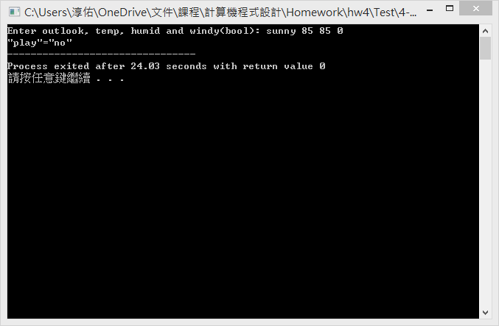

(4-1-2.cpp)(Q1 Additional)

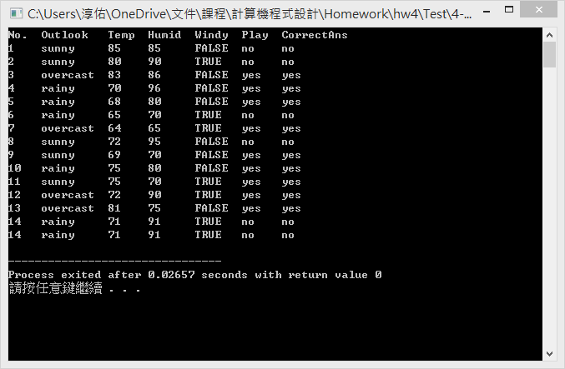

(Q2)

